## Task 1: Creating a RDS Database

1. Navigate to Services at the top and choose RDS under the Database section.
2. Make sure you are in the N.Virginia region.
3. Click on  in the Databases section on the left side bar.
4. Specify DB Details:

* Instance specifications
  + Database creation method : Standard create
  + Engine options : Select MySQL
  + Version : Default
  + Templates : Select Free tier
  + DB instance identifier : Enter *dbinstance*
  + Master username. : Enter *dbuser*
  + Master password and Confirm password: Enter *labdatabase*Note: This is the username/password combo used to log onto your database. Please make note of them somewhere safe.
  + Under Instance Configurations : DB instance class : Select Burstable classes db.t2.micro — 1 vCPUs, 1 GiB RAM
  + Storage type: Select General Purpose SSD (gp2)
  + Allocated storage: Select 20
  + Enable storage autoscaling: Uncheck
  + Virtual Private Cloud(VPC) : Select Default VPC
  + Subnet group : Select Default
  + Public Access : Select Yes
  + VPC Security groups : Select Create new
  + New VPC security group name : Enter *sg*
  + Scroll down to Additional Configuration options
    - Initial database name: Enter *db*
    - DB parameter group: Select default
    - Option group: Select default
    - Enable automated backups: uncheck
    - Enable Enhanced monitoring: uncheck
    - Enable auto minor version upgrade: uncheck
    - Maintenance window: Select No preference
    - Enable deletion protection: uncheck

Note: Leave all the other settings as default

1. Once all the configurations are done properly, click on .
2. Click on the created database dbinstance. Under Connectivity and Security, click the VPC Security groups.

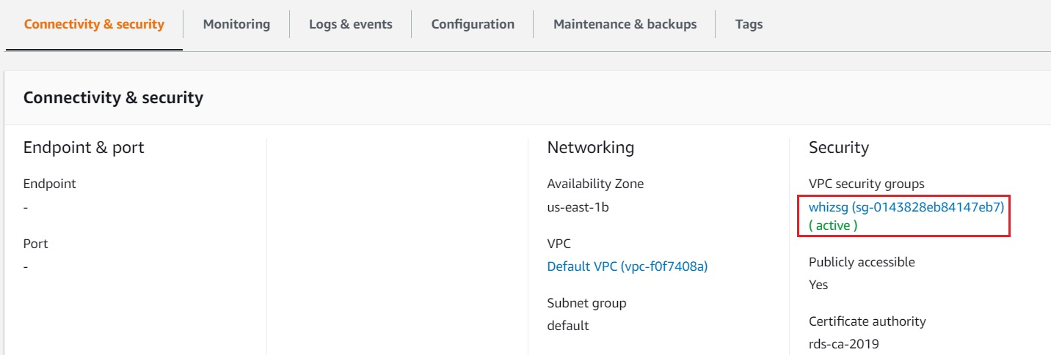

1. Choose the Inbound Rules tab below and click on Edit Inbound Rules.

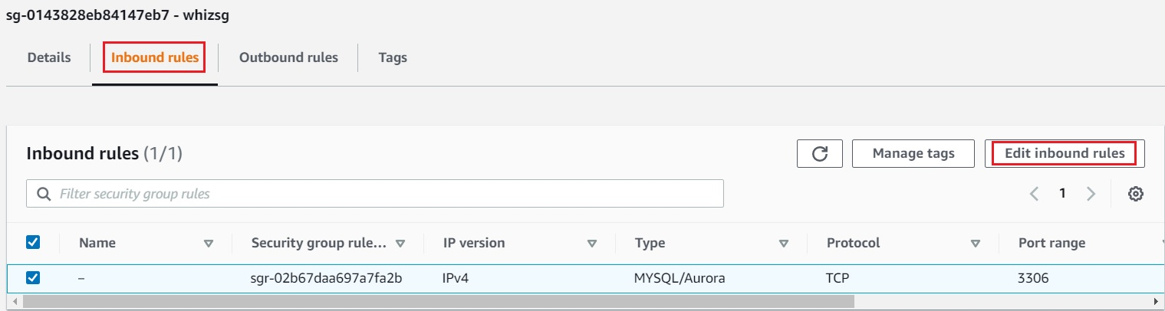

1. Remove the source of IP address and select Anywhere-IPv4 (0.0.0.0/0) and click on Save rules.

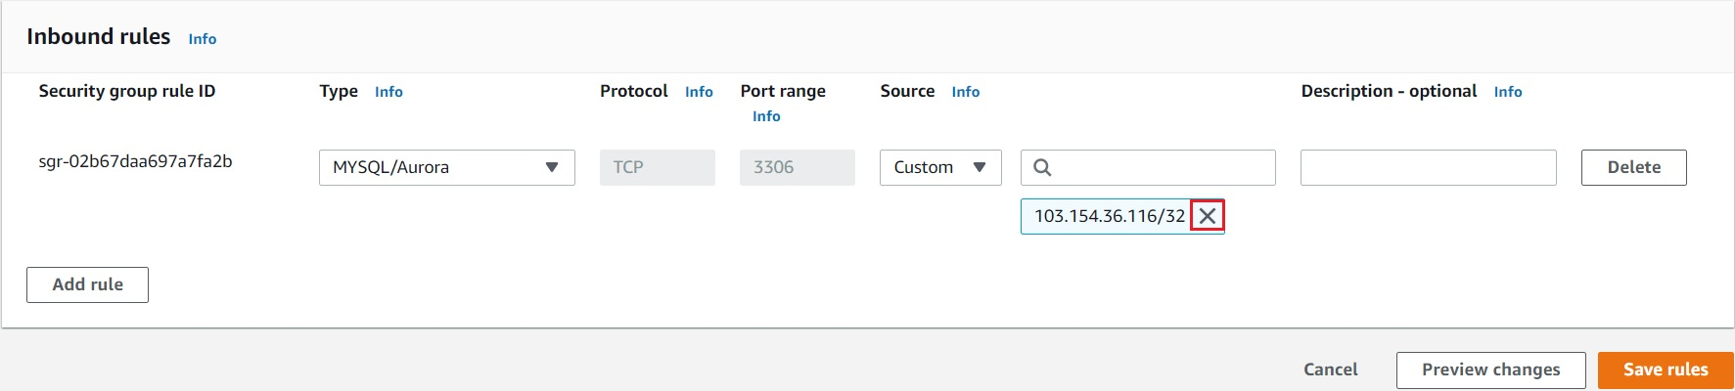

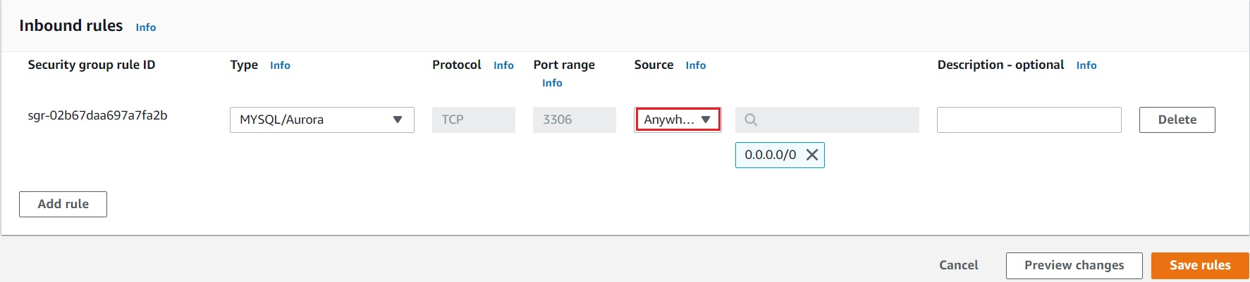

1. Navigate to Services and click on RDS under Database
2. Click on  in the left panel.
3. On the RDS console, the details for the new DB instance appear. The DB instance has a status of creating until the DB instance is ready to use. When the state changes to Available, you can connect to the DB instance. It can take up to 20 minutes before the new instance status becomes Available.

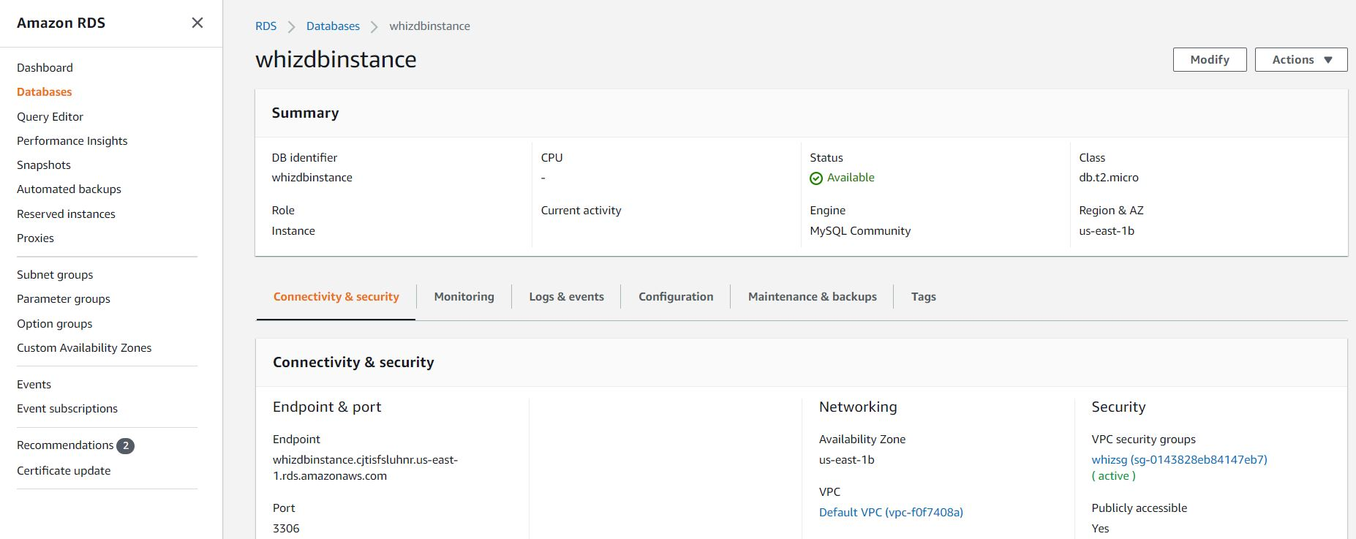

## Task 2: Connecting to RDS Database

1. To connect to a database on a DB instance using MySQL monitor, find the endpoint (DNS name) and port number for your DB Instance.
   * Navigate to  and click on dbinstance.
   * Under Connectivity & security section, copy and note the endpoint & port.
     + Endpoint example: dbinstance.cjxskndztif9.us-east-1.rds.amazonaws.com
     + Port: 3306

(Note: You need both the endpoint and the port number to connect to the DB instance.)

1. First, download and install MYSQL Workbench on your local machine.
2. Start MySQL Workbench and click on .
   * Enter the Connection Name : Enter *db*
   * Hostname : copy / paste the Endpoint
   * Username: *dbuser* (your Master Username)
   * Password: Click on Store in Vault button and enter *labdatabase* (your Master password)
3. Click on Test Connection and click on OK on the pop up box. Click on OK again after the connection is successful.

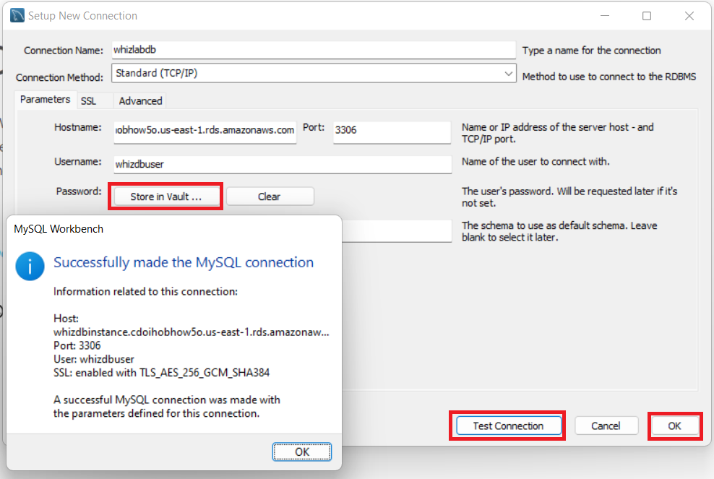

1. Click on the connection created, ie., db to open the editor.
2. In the editor type
3. show databases;
4. and click on the  button. Now you will see the database db below in the result.

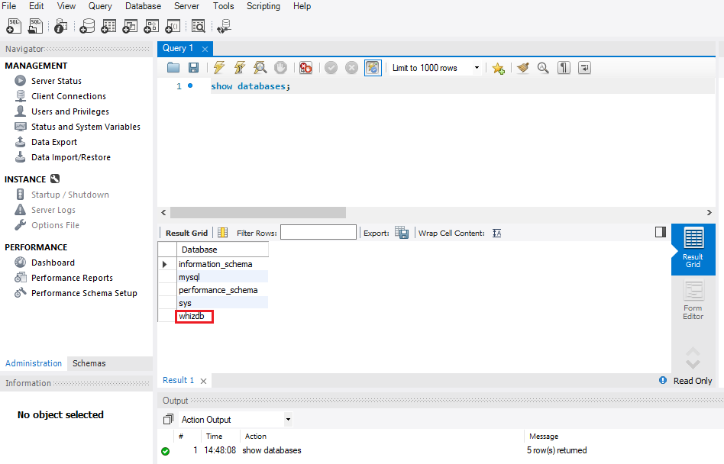

## Task 3: Creating a Snapshot

1. Navigate back to Amazon RDS page.
2. Now take a snapshot by clicking on Snapshots in the left side panel and then on 
3. Select the DB Instance you created (i.e dbinstance) to take a snapshot.
4. Enter the snapshot name : *snap* and click on Take Snapshot.
5. Wait for 3-5 minutes for snapshot creation. Once the snapshot is created successfully, your screen will look similar to the screenshot below.

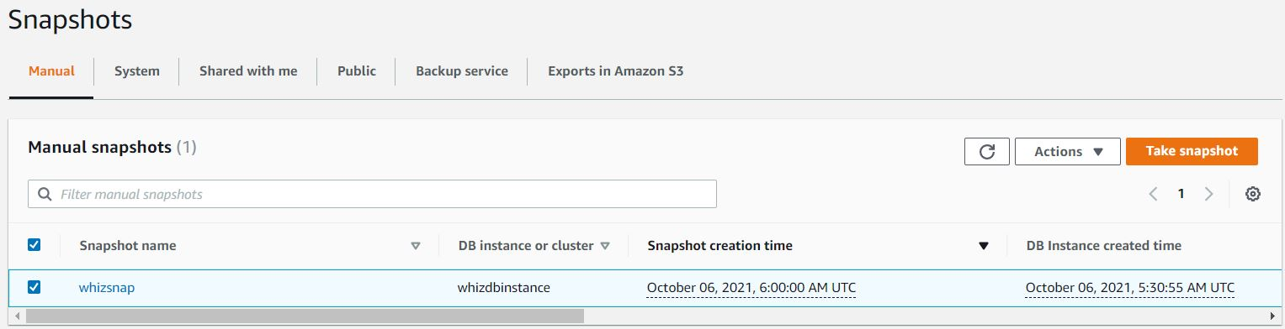

1. You can check the snapshot details by clicking on the snapshot and viewing the details of your DB Instance.

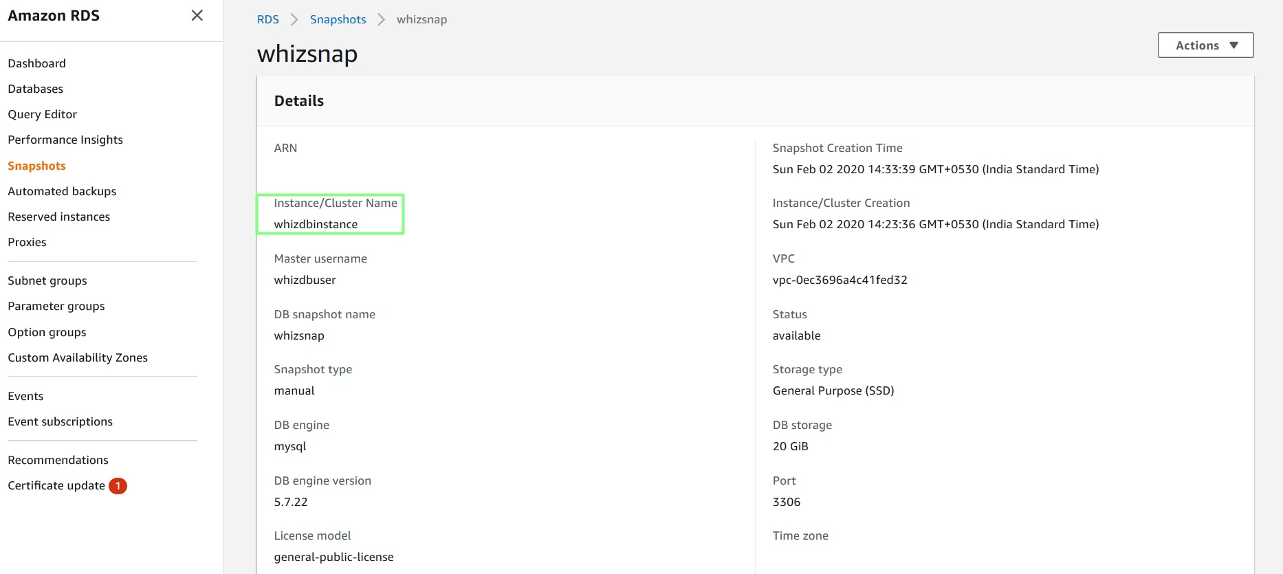

## Task 4: Creating a Backup

1. Enter into the snapshot created above and click on Actions button on the top right corner and then choose Restore Snapshot.
2. DB specifications
   * Engine : Select MySQL Community
3. Settings
   * DB Instance Identifier : Enter *snaprestore*
4. Availability & durability

* Multi-AZ deployment : Select Single DB Instance.

1. Connectivity
   * Virtual Private Cloud (VPC) : default VPC
   * Subnet group : default
   * Public access : Select Yes
   * VPC security groups :
     + VPC security group : Select Choose Existing
     + Remove the default security group which is selected by default.
     + Select Security group created by the above database (sg).
     + Availability Zone : Select No preference (Default)
   * Expand Additional configuration
     + Database port : Default 3306
2. DB instance size
   * DB instance class : Select Burstable classes (includes t classes)
   * Select db.t3.micro (Default)
3. Storage
   * Storage type : Select General Purpose SSD (gp2)
   * Allocated storage : 20
4. Database authentication
   * Database authentication options : Select Password authentication (Default)
5. Additional configuration
   * Leave everything as default
6. Click on Restore DB Instance.

(Note : It will take up to 20 minutes to create the Restore DB Instance.)

1. The restored instance will be created in a different AZ. Now you have successfully completed the lab.

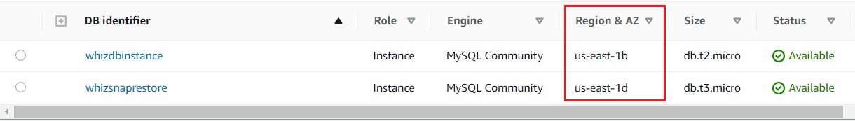

1. Click on naprestore.
2. Under Connectivity & security section, copy and note the endpoint & port.

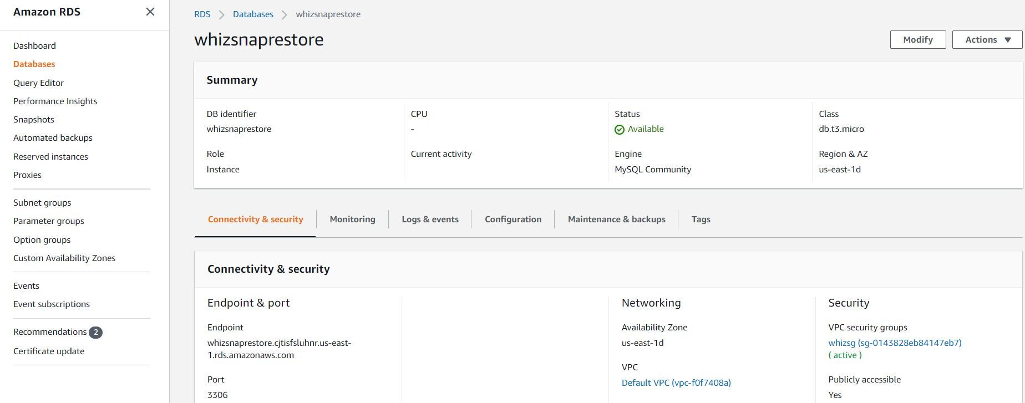

## Task 5: Connecting to a Backup Database

1. Navigate to MySQL Workbench and click on .
   * Connection Name : Enter *restore db*
   * Host Name : Paste the above Endpoint.

* Username : Enter *dbuser* (Master Username)
* Password: Click on Store in Vault and enter *database* (The password will be the same as above)

1. Click on Test Connection and click on OK on the pop up box. Click on OK again after the connection is successful.

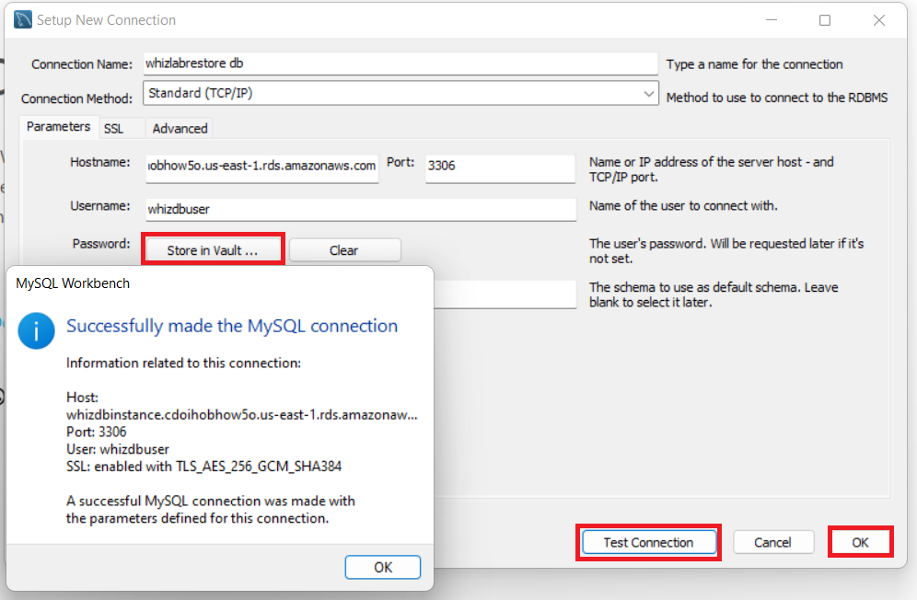

1. Click on the connection created, ie., *restore db* to open the editor.
2. In the editor type
3. show databases;
4. and click on the  button. Now you will see the database db below in the result.



## Task 6: Delete AWS Resources

### Deleting RDS database

1. Navigate to RDS by clicking on the  menu available under the Database section.
2. Click on Databases.
3. It will list all the RDS databases.
4. Click on Actions and select Delete  
   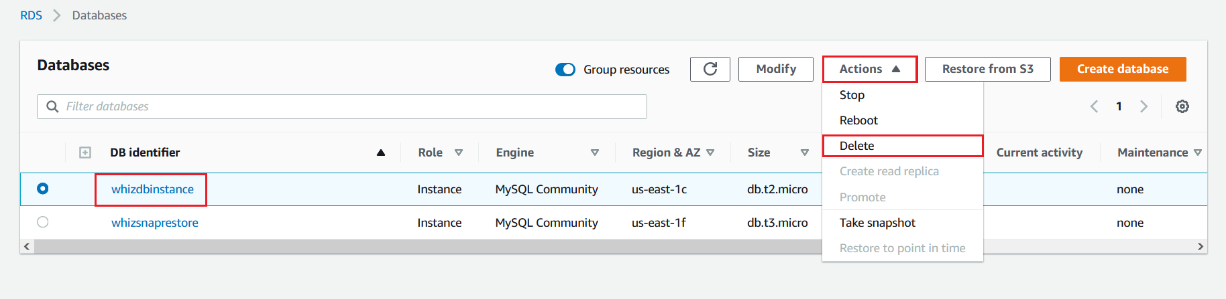
5. To delete we have to perform several tasks:
   * Uncheck the option Create final snapshot
   * Acknowledge by selecting the second option.
   * Type delete me to confirm
   * And finally, click on Delete button below.  
     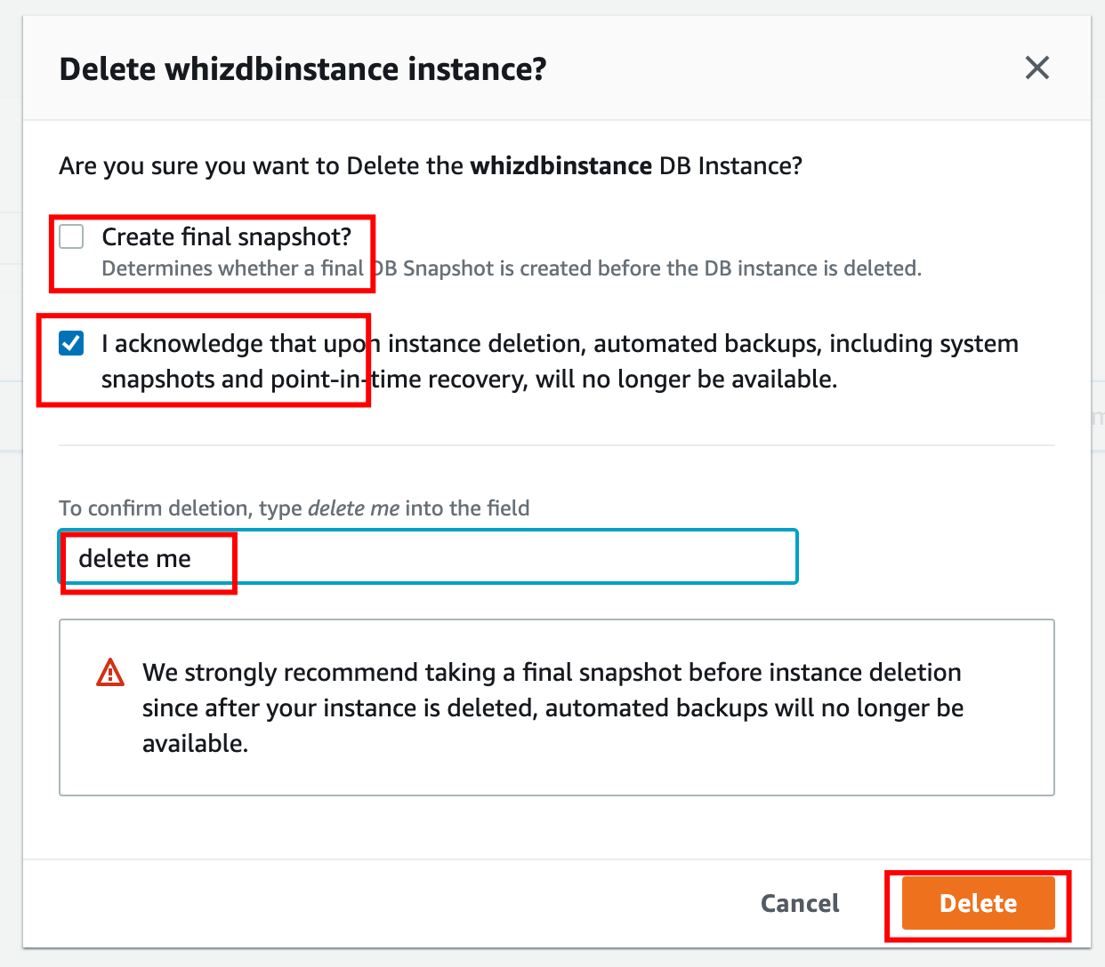
6. It will take around 5 minutes to delete the instance, now repeat the steps to delete the other RDS databases also.  
   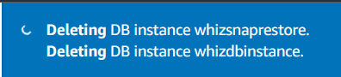

### Deleting RDS snapshot

1. Navigate to RDS by clicking on the  menu available under the Database section.
2. Click on a snapshot in the left sidebar
3. It will list all the RDS databases  
   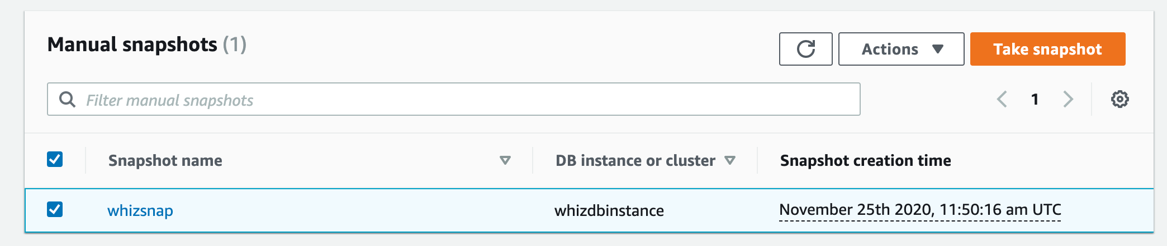
4. Click on Actions and select Delete snapshot  
   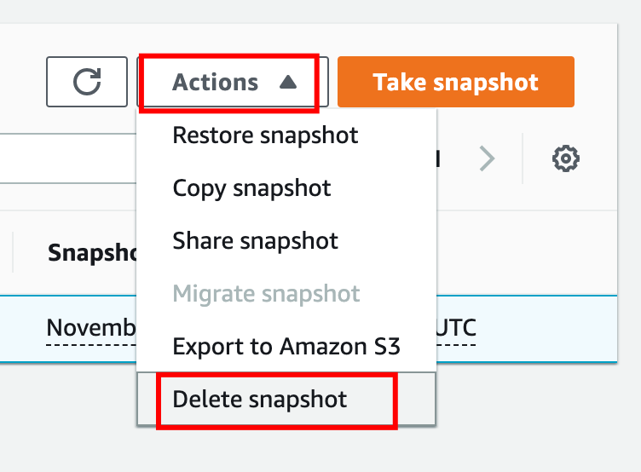
5. Now click on the Delete button.  
   